**MAVEN WEB PROJECT DEPLOYMENT IN THE AWS CLOUD USING EC2 INSTANCE**

**Search for AWS academy login**

**Click on Student Login.**

**Enter your details and login.** 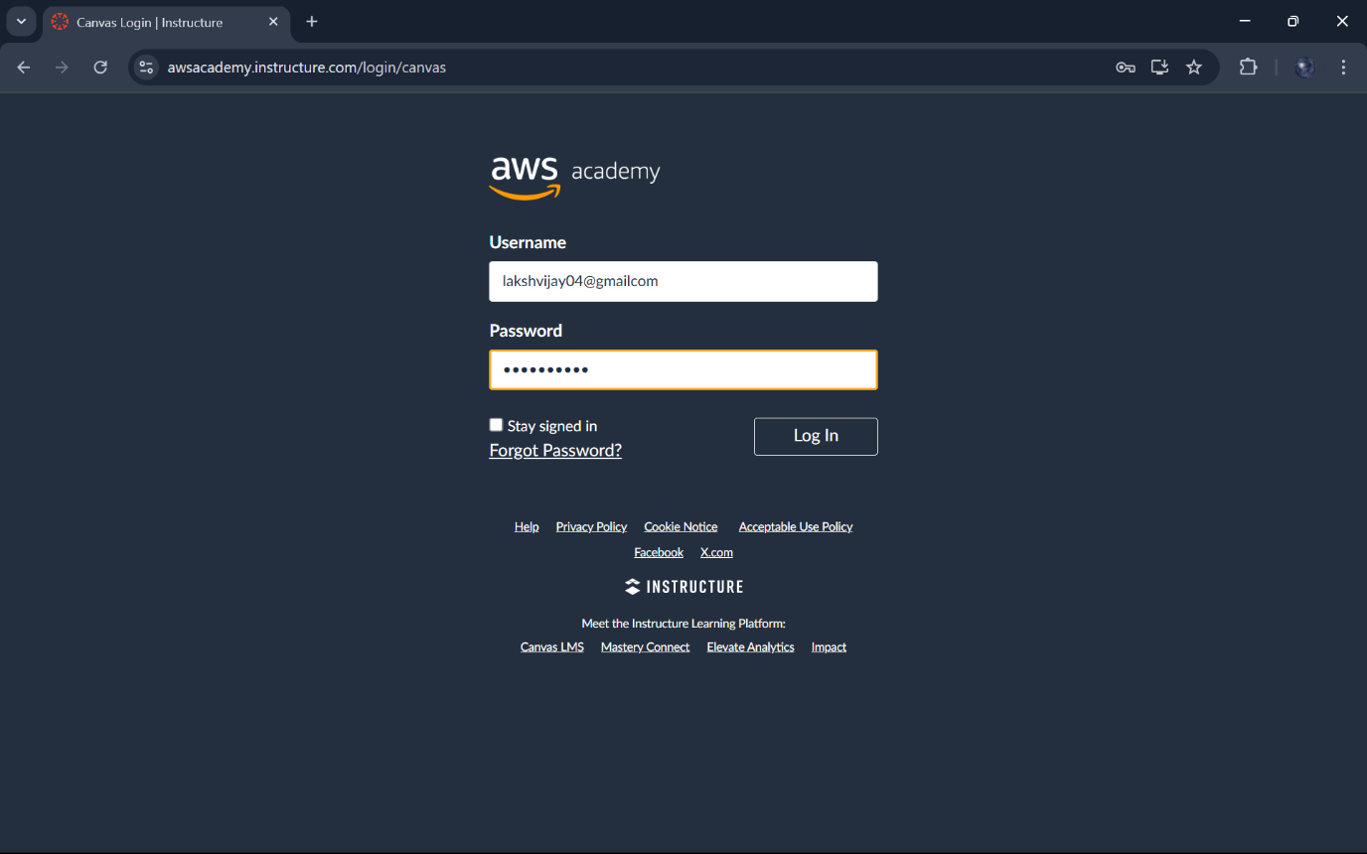

**Click on AWS Academy Learner Lab ->Modules**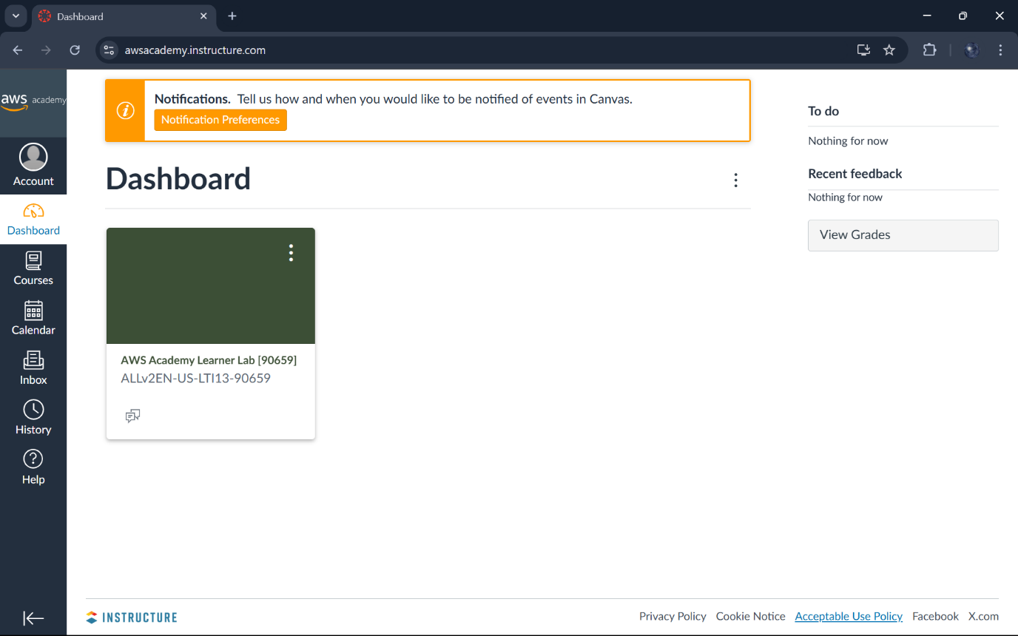

**Click on Launch AWS Academy Learner Lab.**

**After Click on Start Lab.**

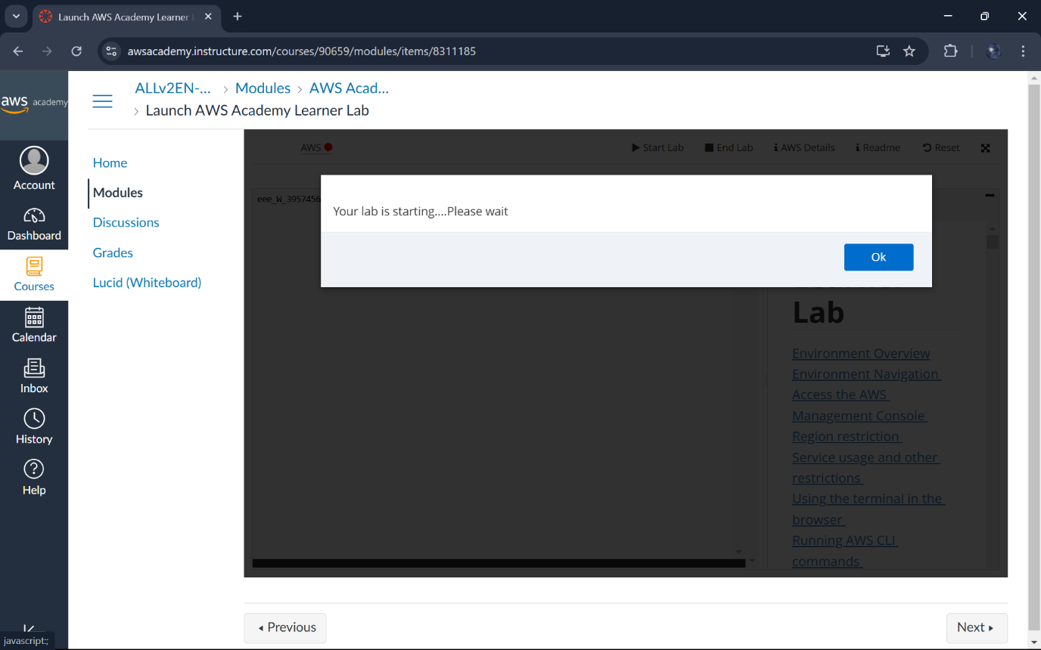**After it became green click on it.** 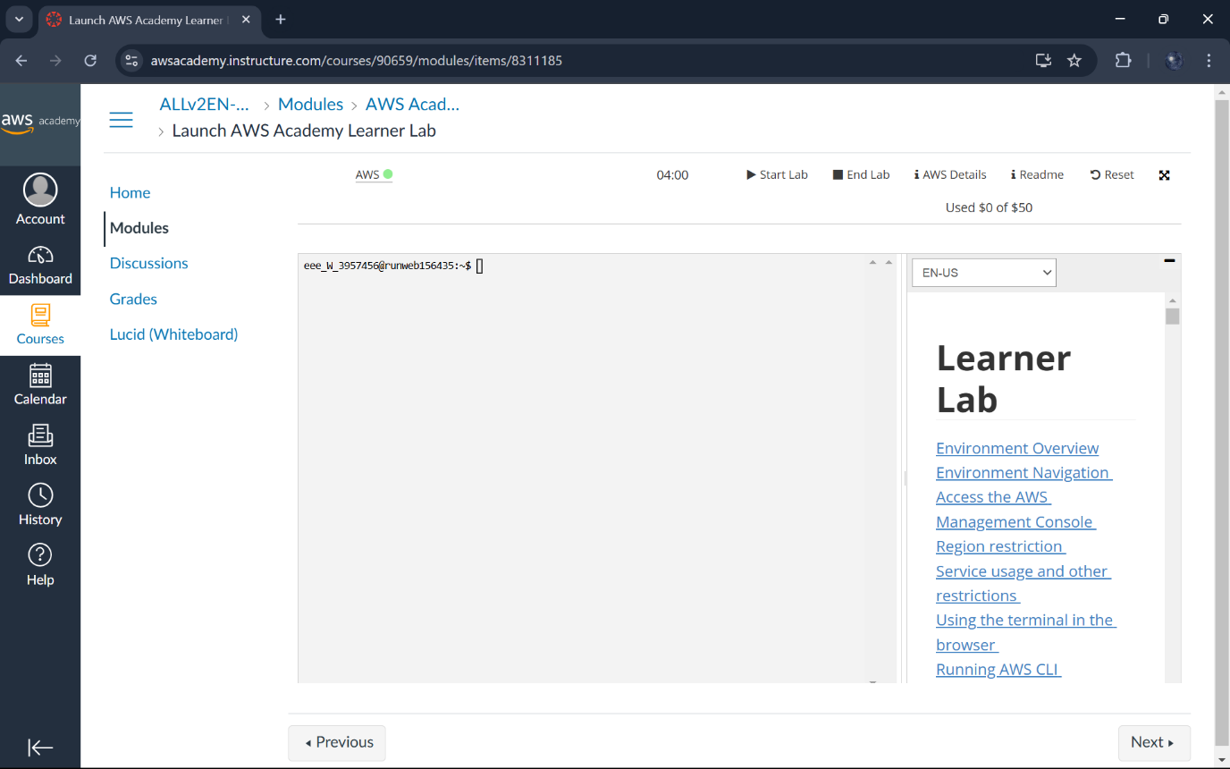

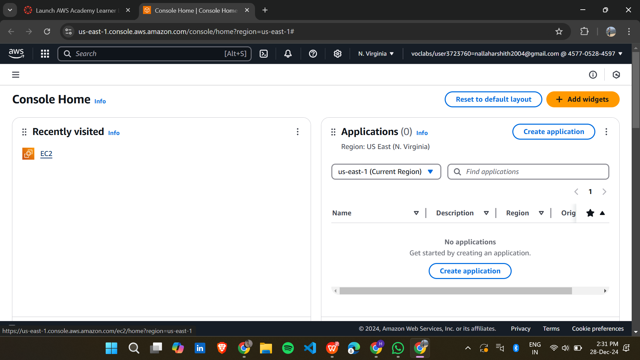

**Click on EC2.**

**Click Launch Instance.** 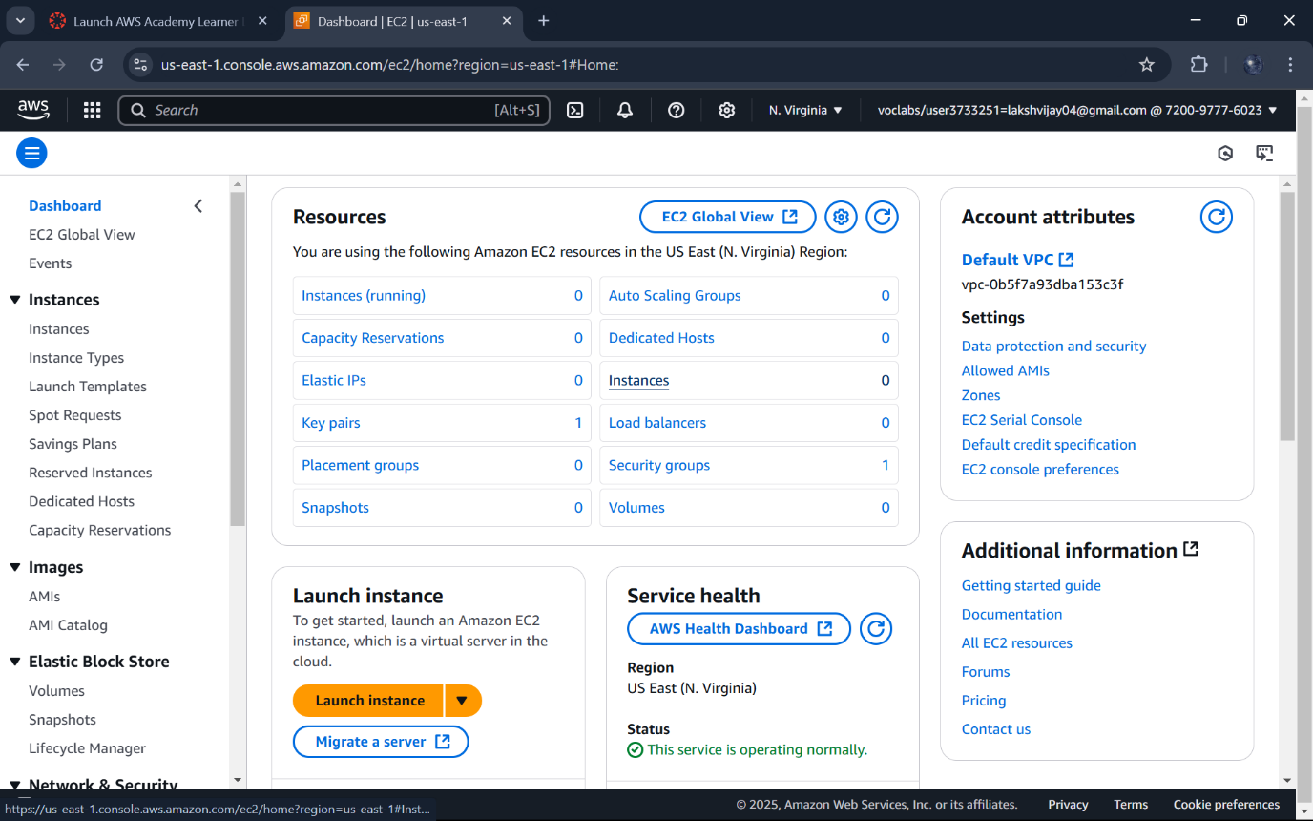

**Enter a descriptive name:ex:MavenWebProjectServer**

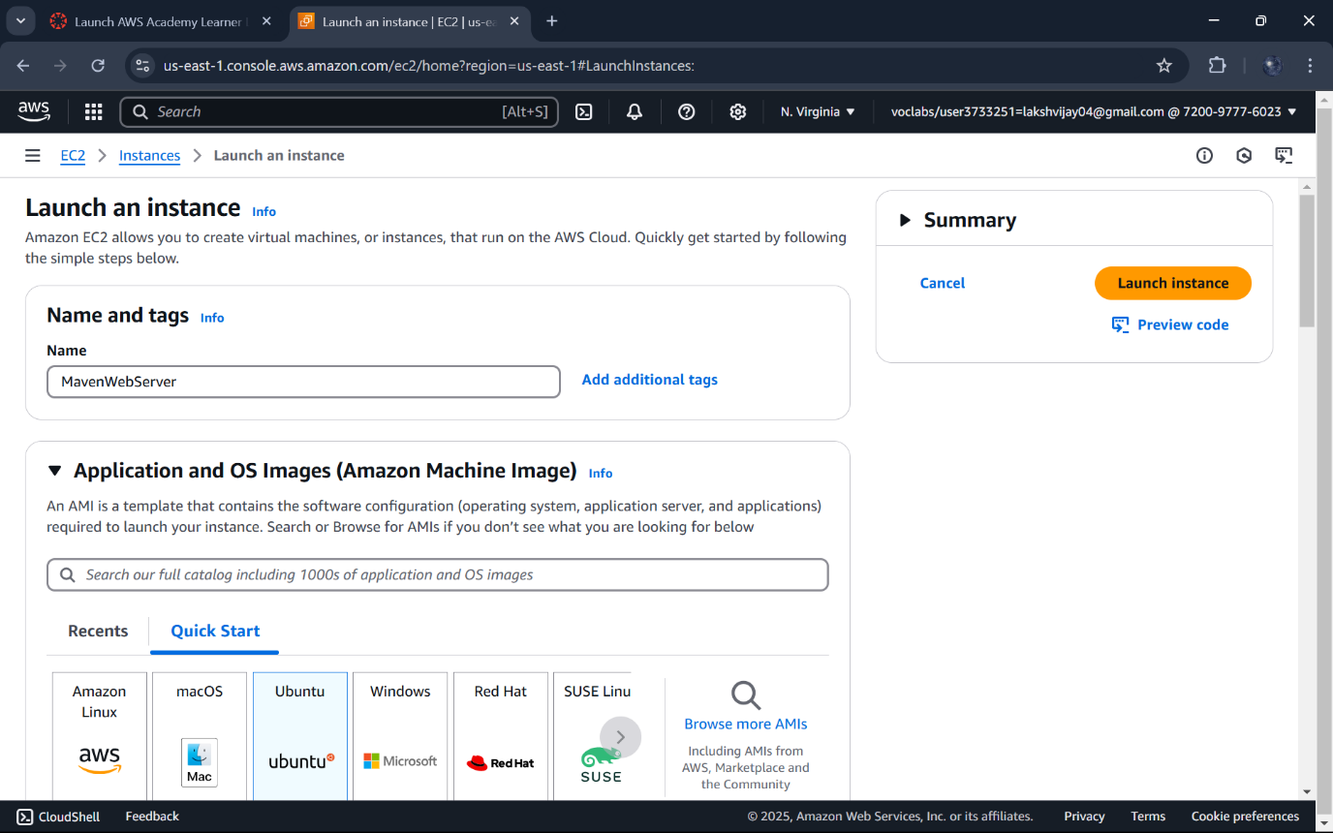

**AMI: Select Ubuntu Server(Free Tire Elgible)**

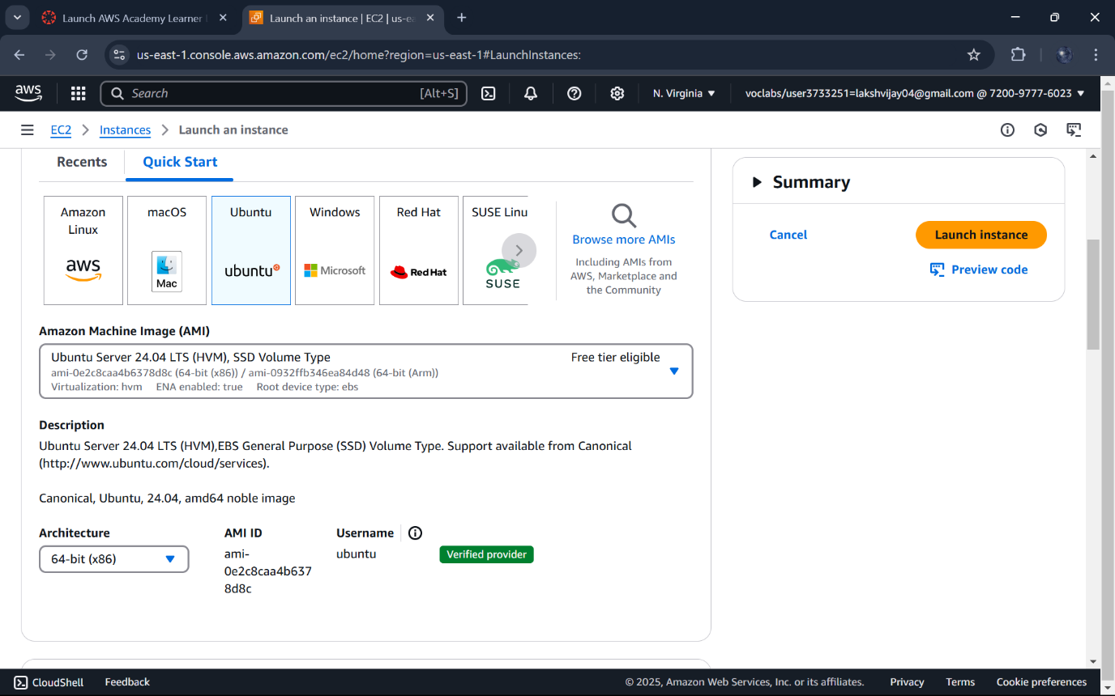

**Instance type:Choose t2.micro**

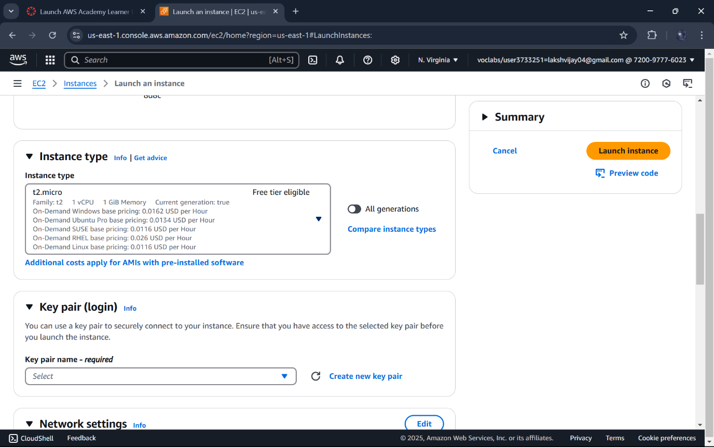

**Key pair:Create a key pair or use an existing one.Save the .pem file securely**

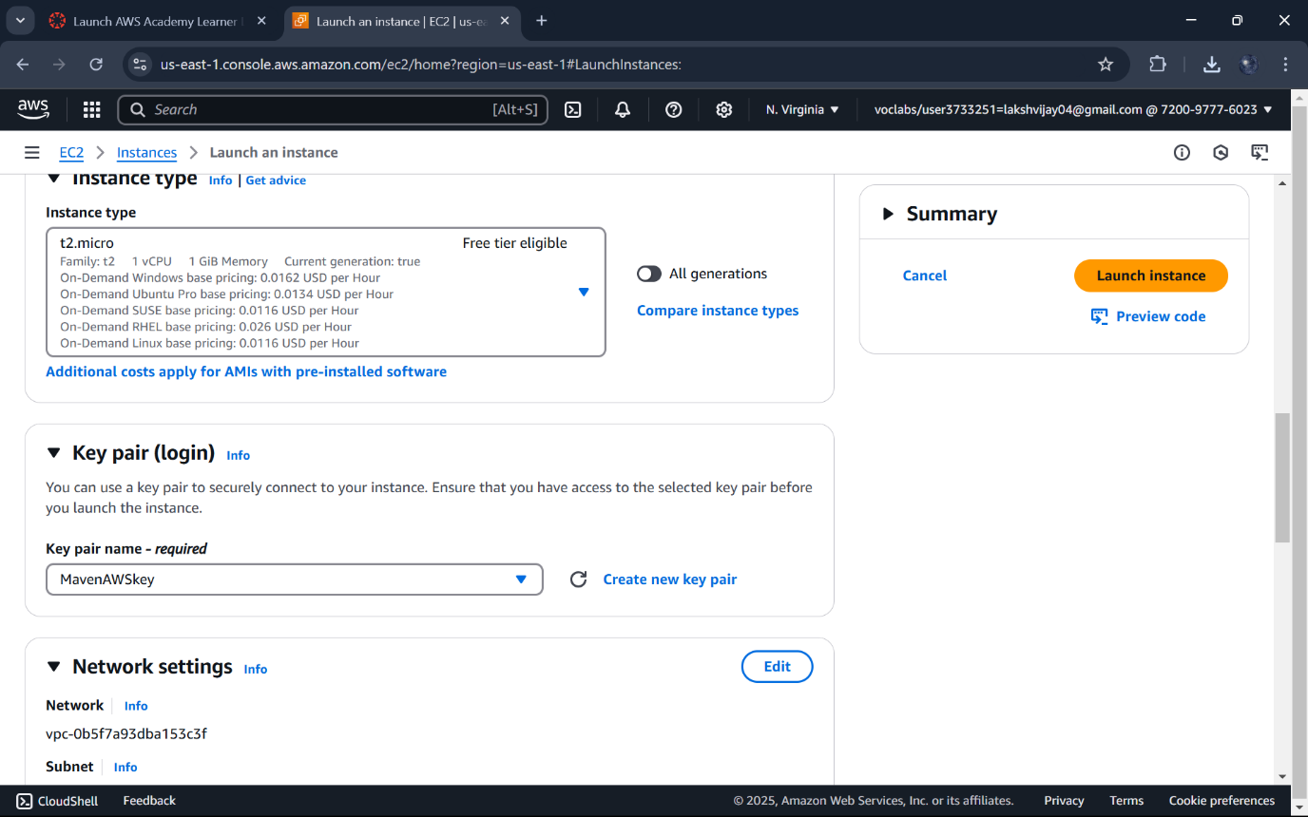

**Network settings:Enable Allow HTTP/HTTPS traffic**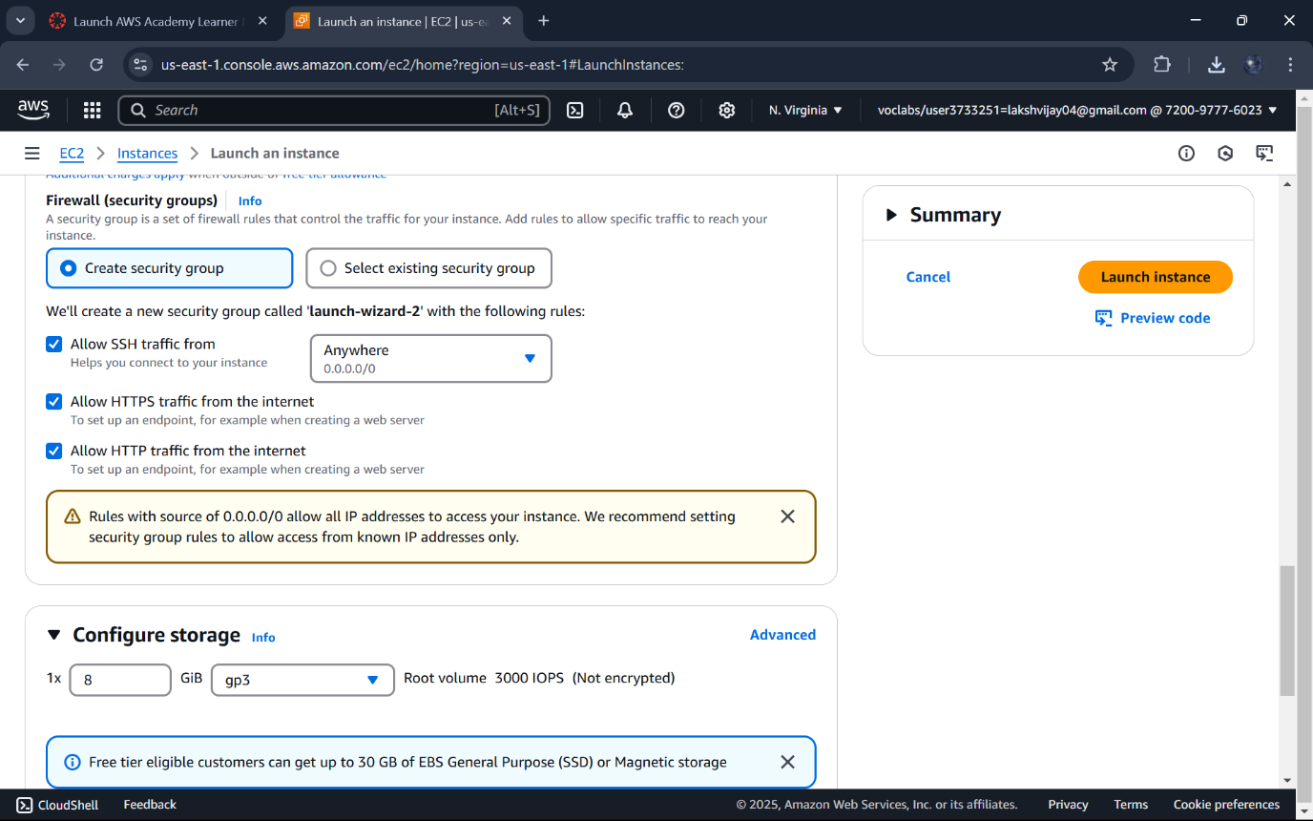

**Instance is initiated.**

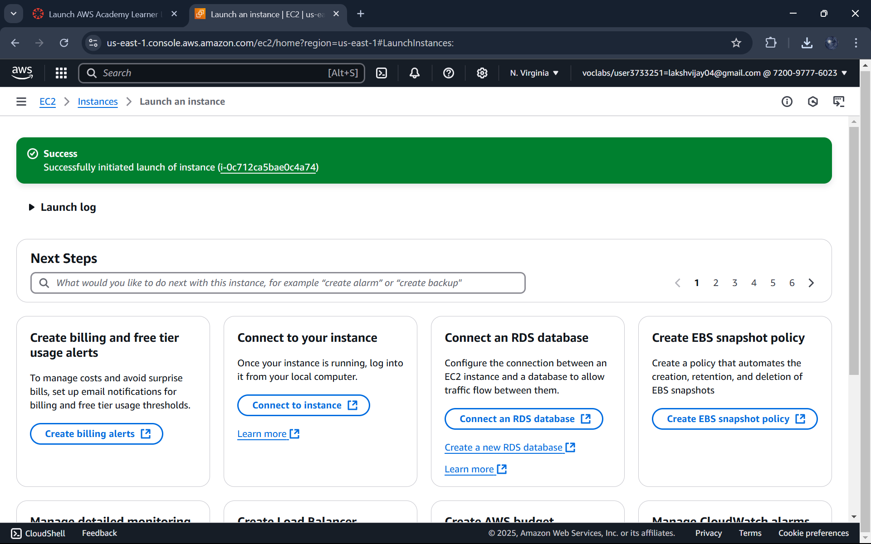

**Wait for the status change to running**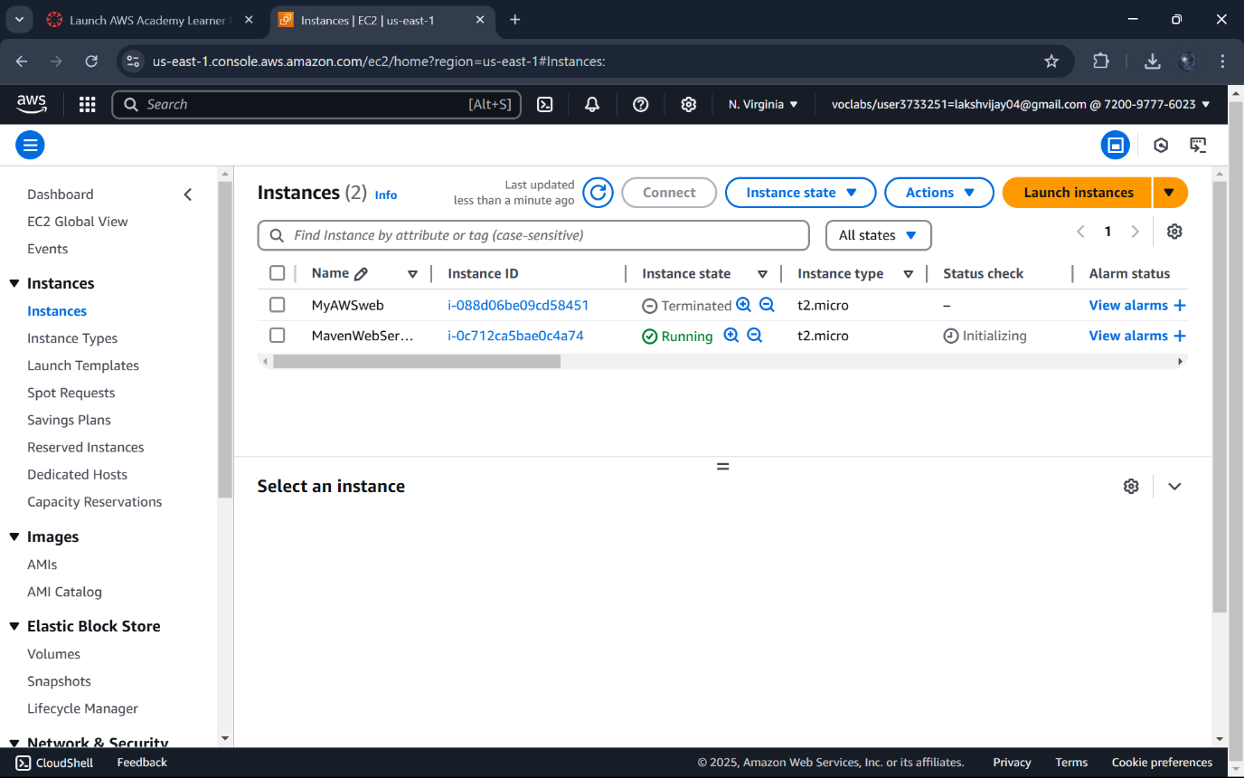

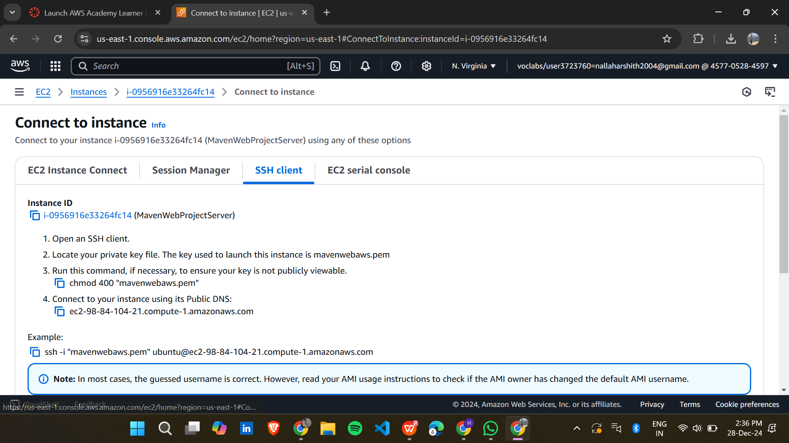

**Select your instance,click Connect ,and copy the SSH command under Example Heading.**

**Create a folder and copy the download .pem file in it.**

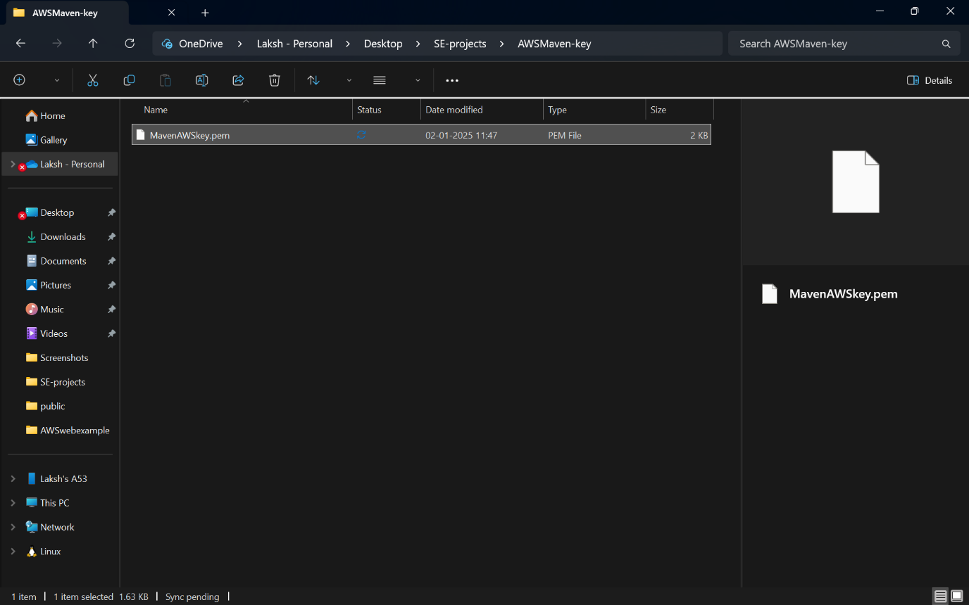

**Open on your computer->Run as administartor**

**Navigate to the folder where you have saved.pem file**

**Paste the SSH command and press enter.**

**If prompted,type “yes” to confirm the connection.**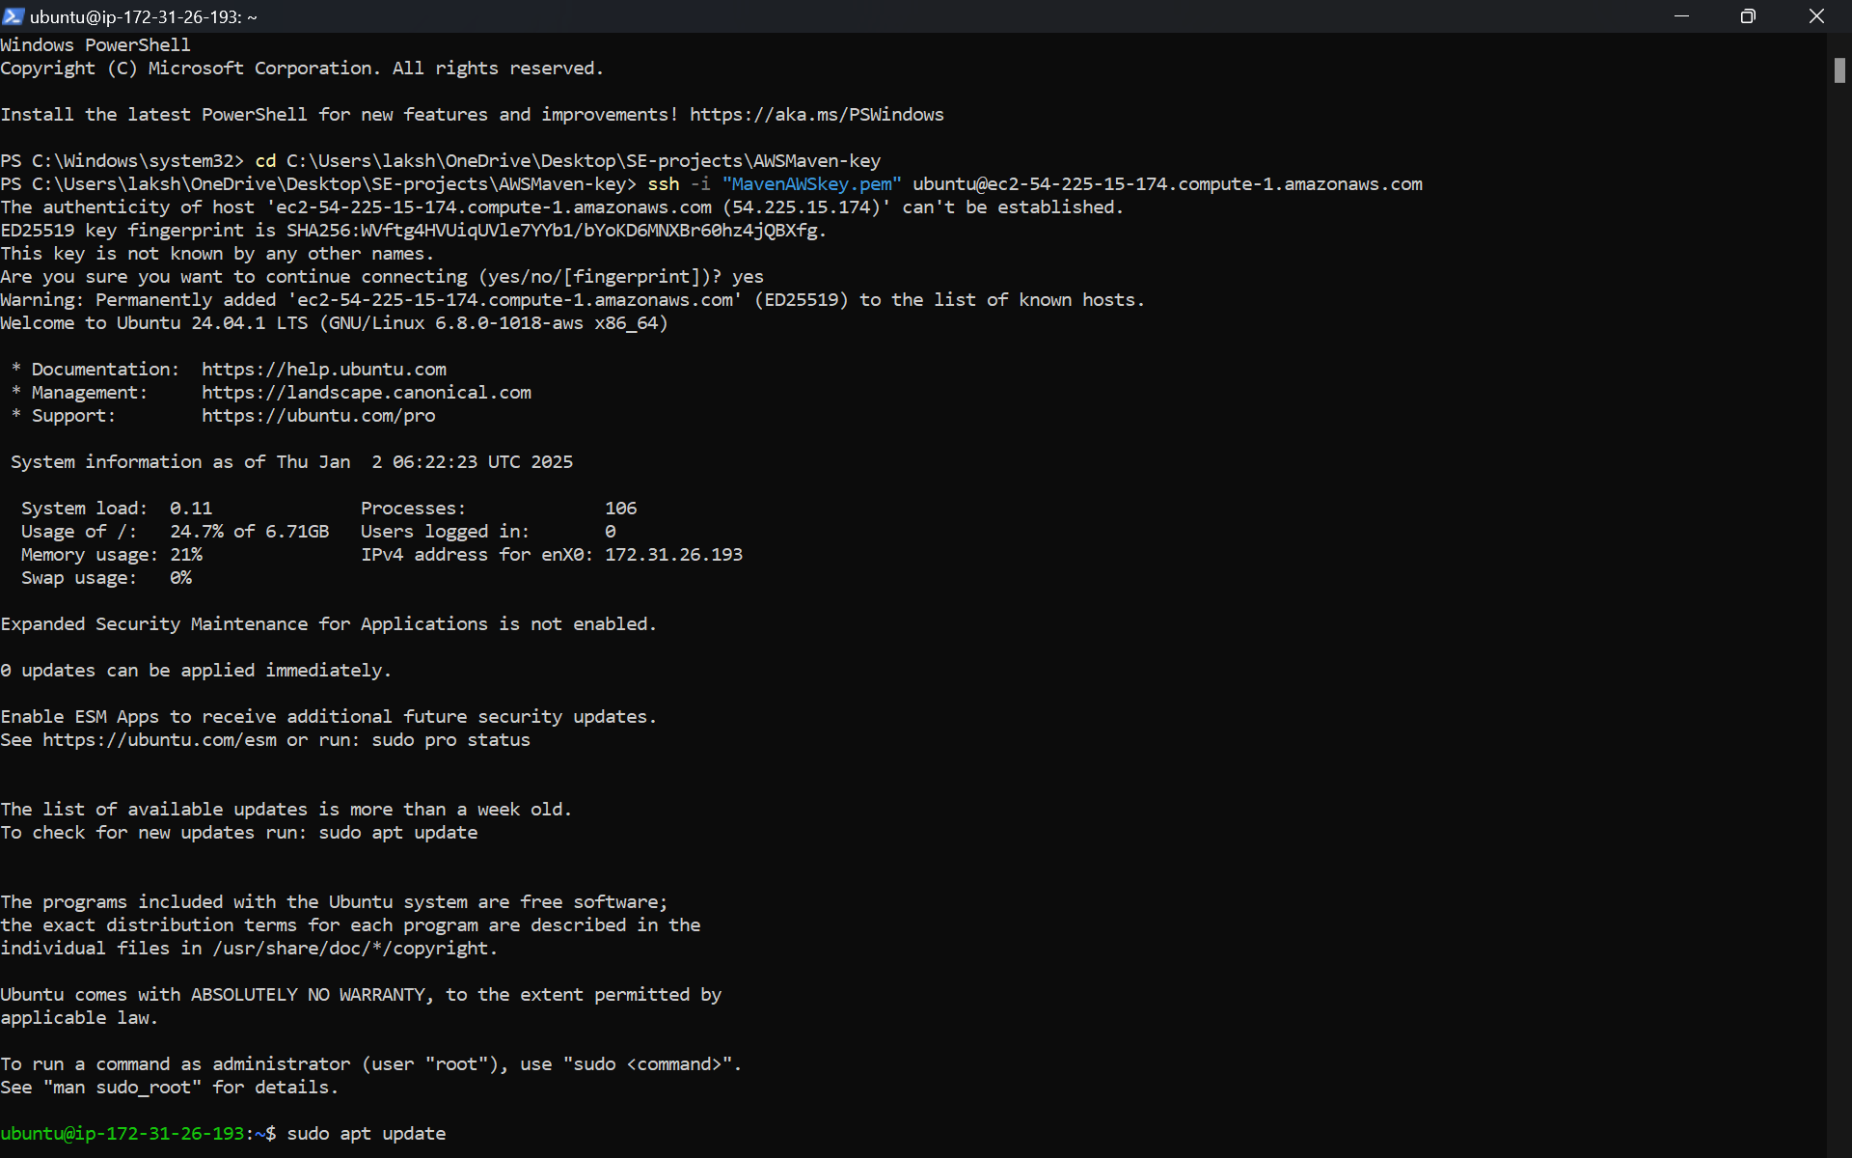

**Update the system:sudo apt update**

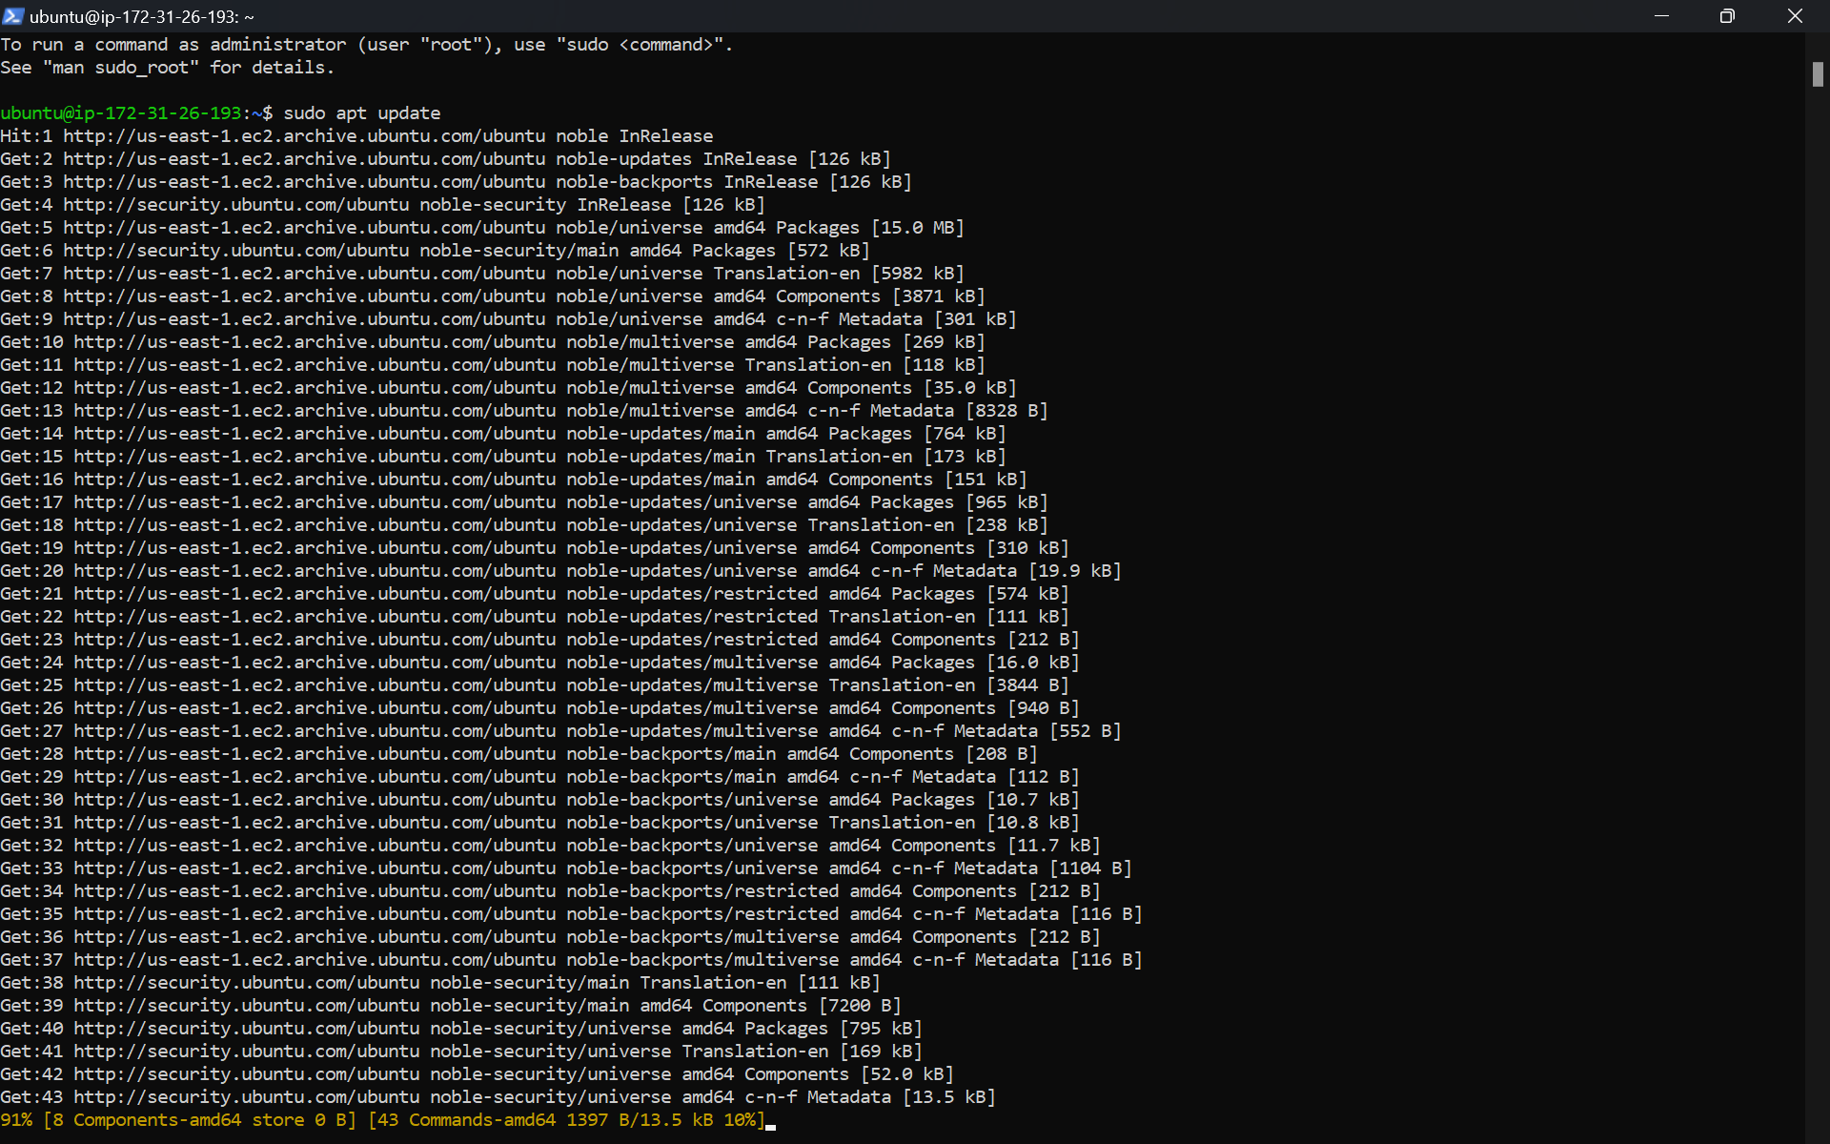

**Install Docker:sudo apt-get install docker.io -y**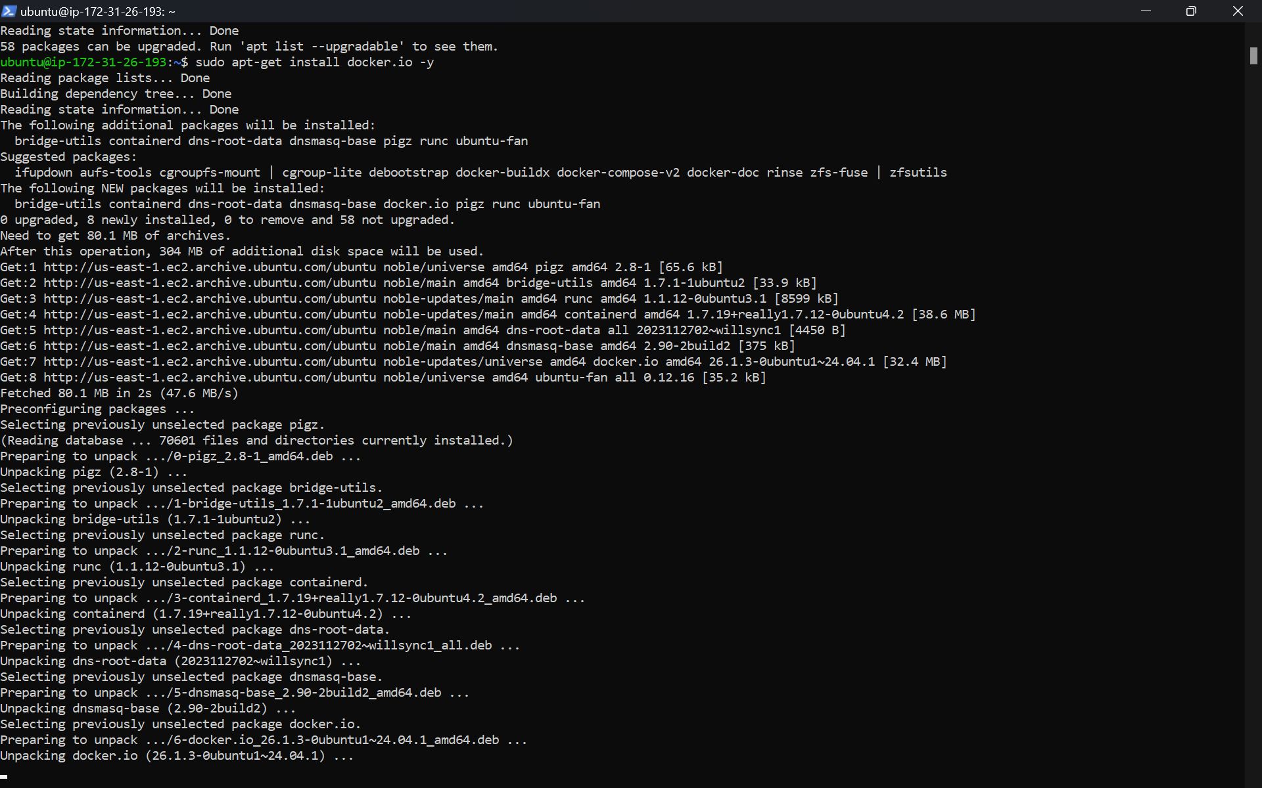

**Install git:sudo apt install git -y**

**Install Nano:sudo apt install nano -y**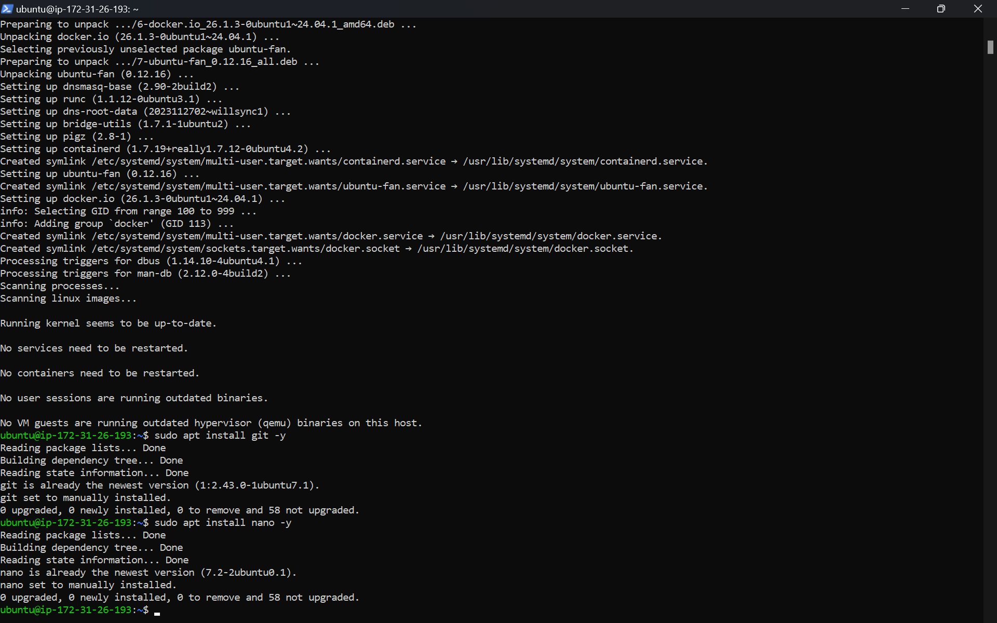

**Go to your github repository and copy your URL.**

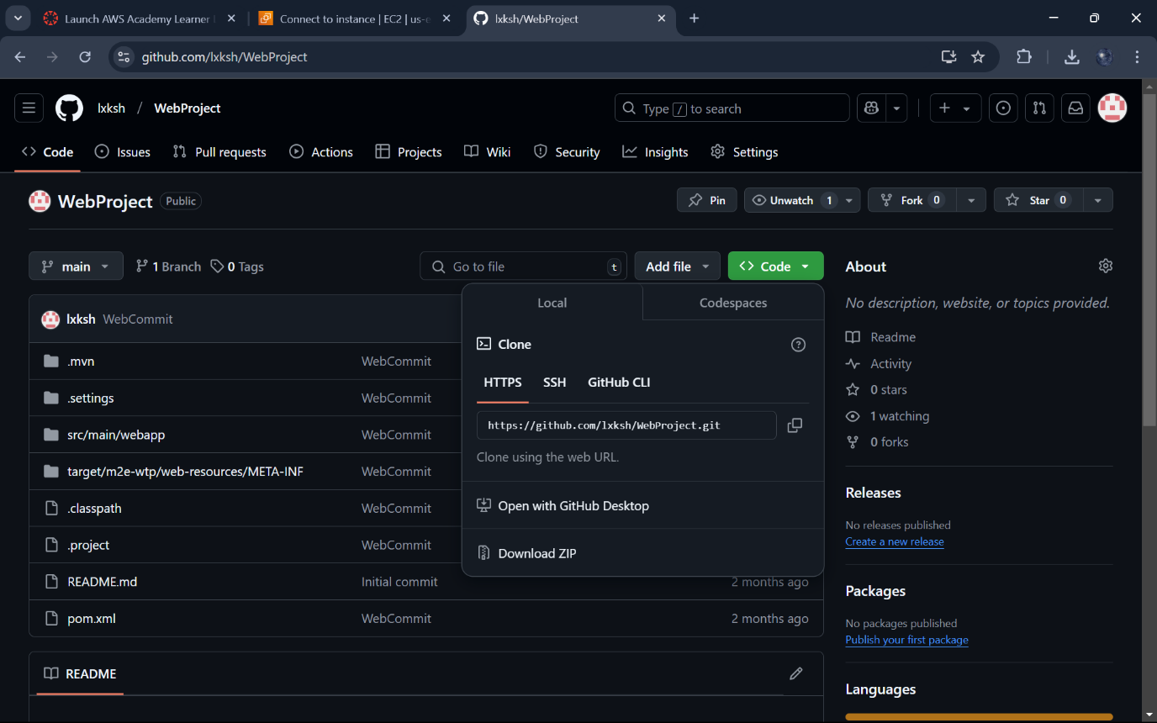

**Clone your repository**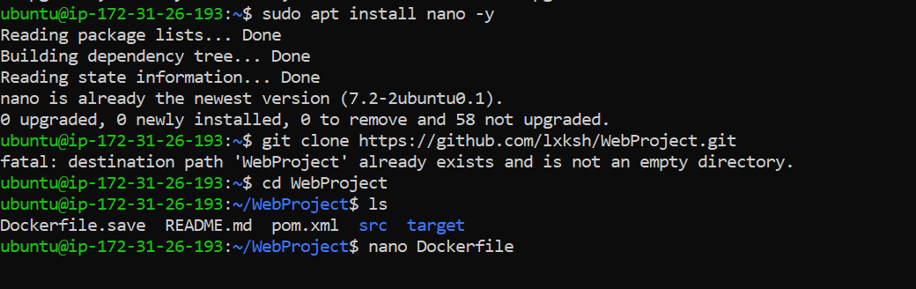

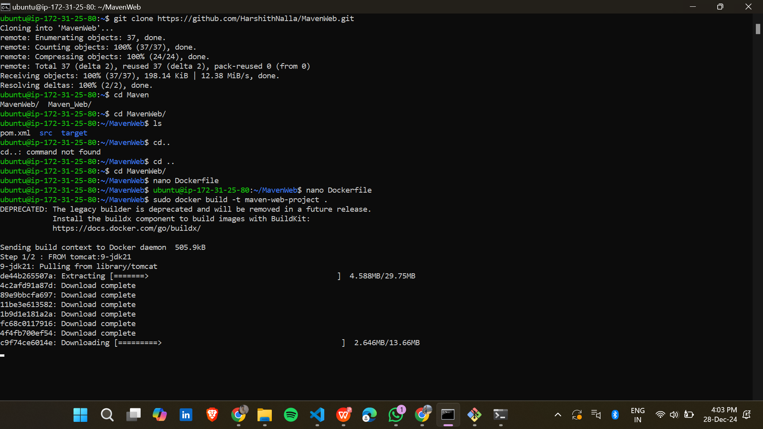

**Navigate to the project folder.**

**Build docker image**

**Sudo docker build -t maven-web-project**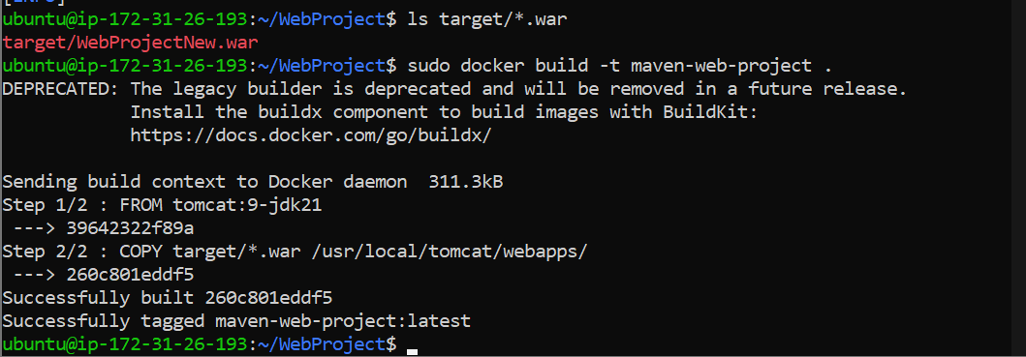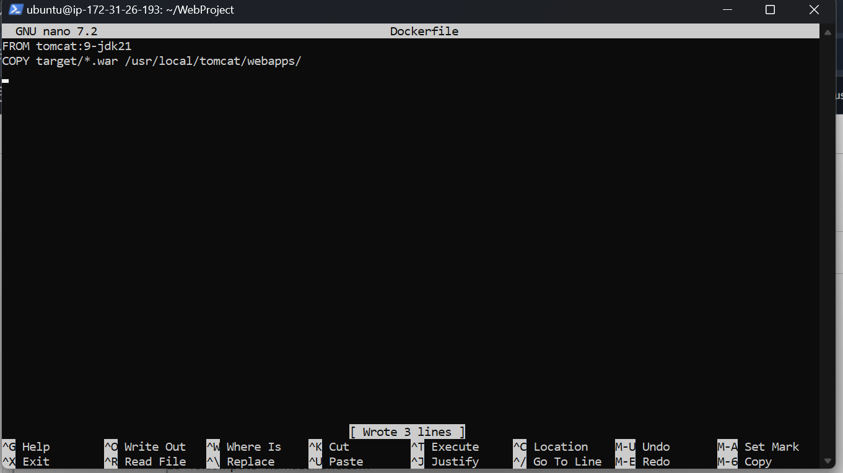

**Add the following content based on JDK version used during development.**

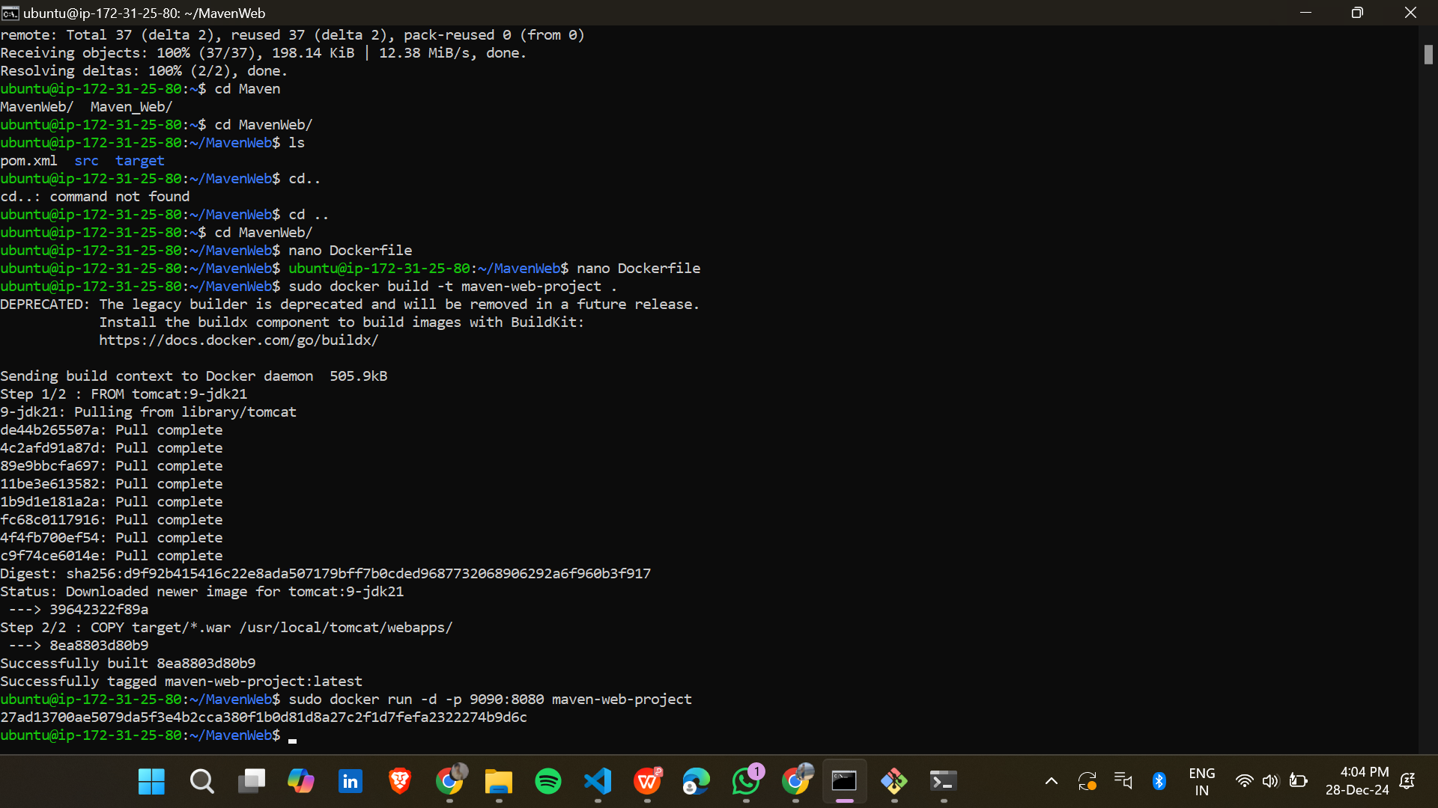

**Run your docker image.** 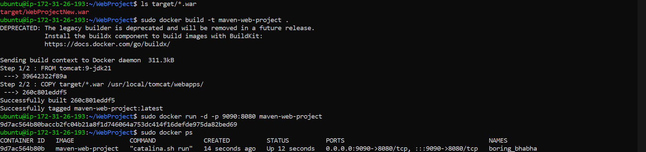

**In the AWS EC2 dashboard,go to security and click the Security group ID**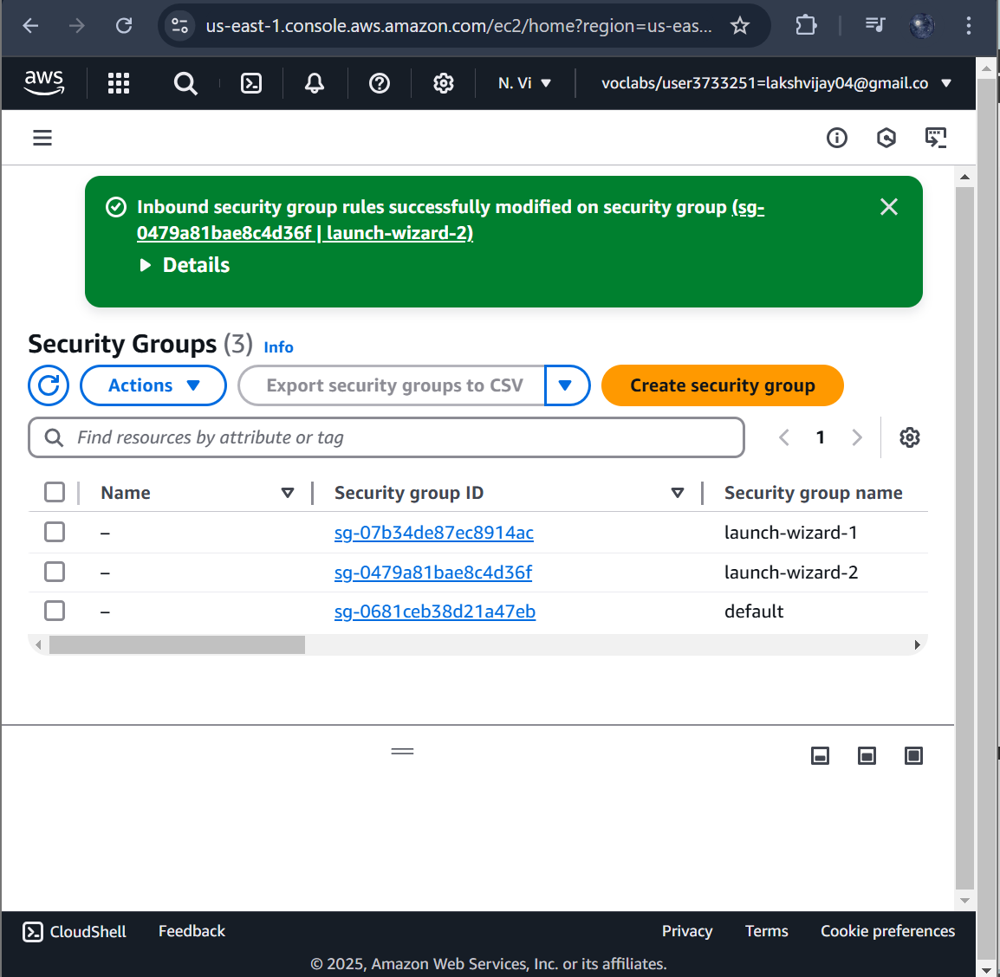

**Add an inbound rule.** 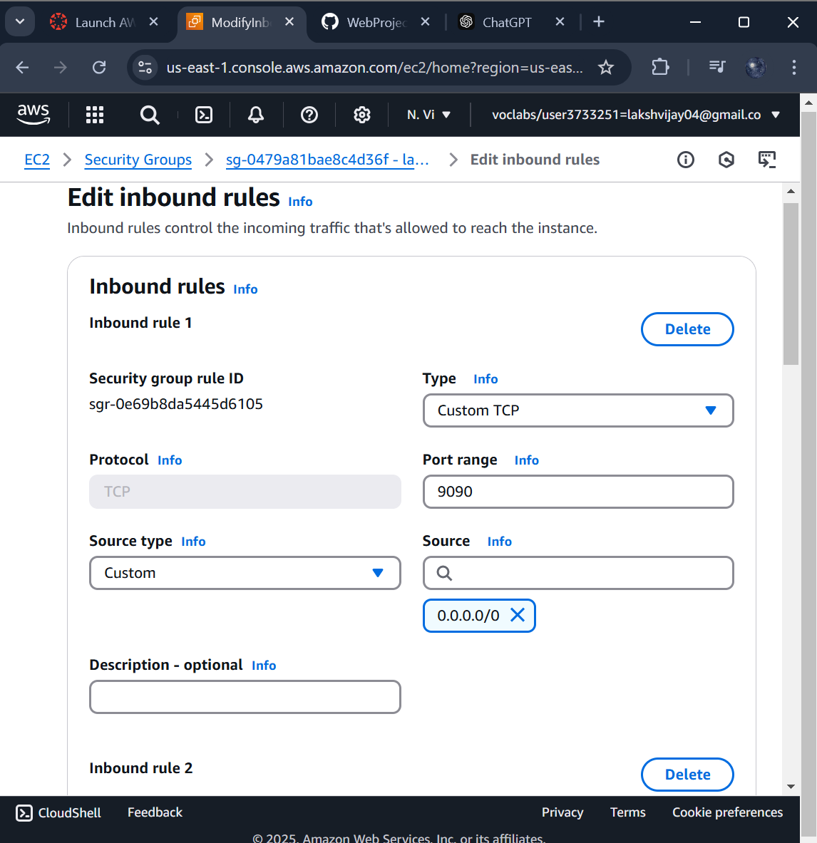

**The changes are successfully saved.**

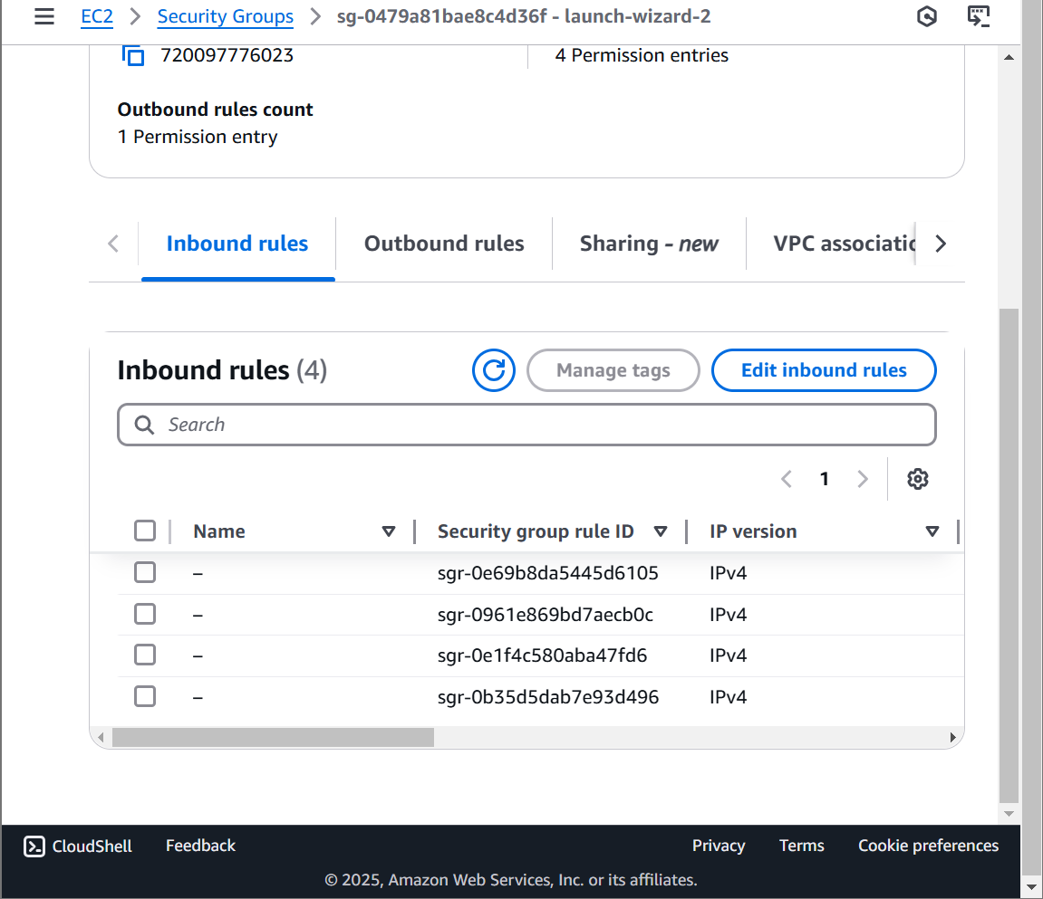

**Copy the public IP address.**

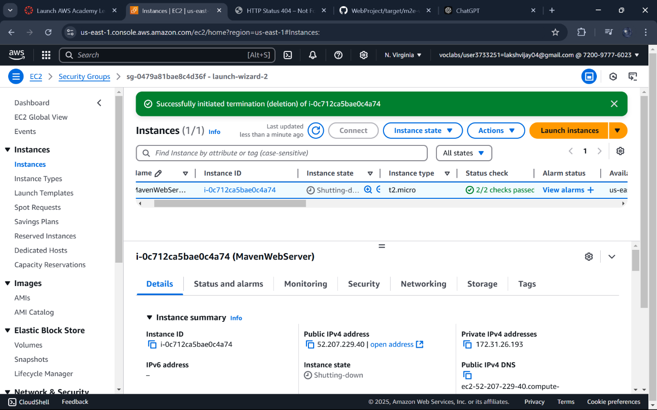

**Open a browser and navigate to the address along with project you will get output as this**

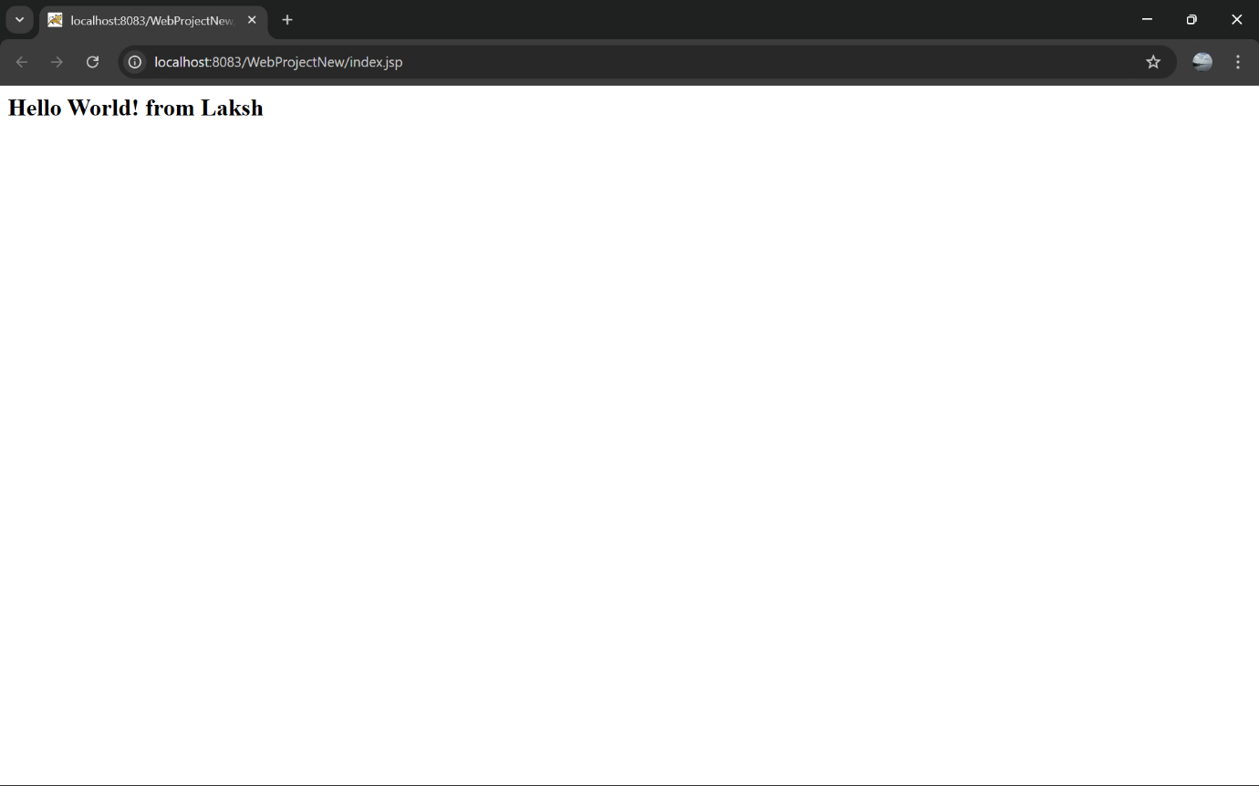

**Sudo docket ps to display all containers**

**Copy the container ID .Stop the docker container ID**

**In the EC2 dashboard go to instance state and select terminate instance**

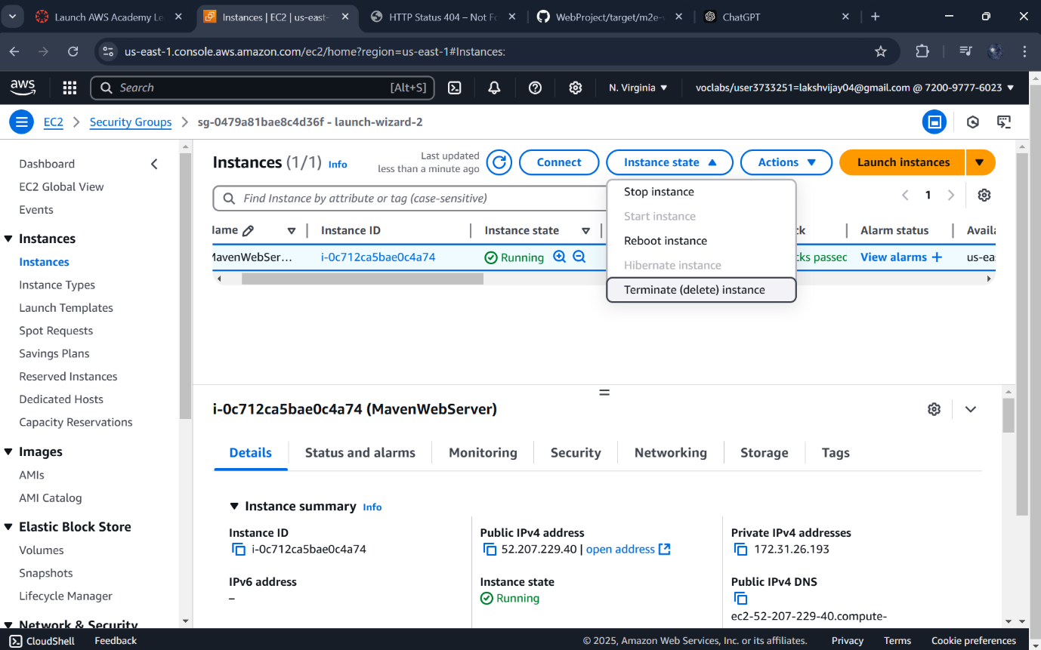

**Click on Terminate**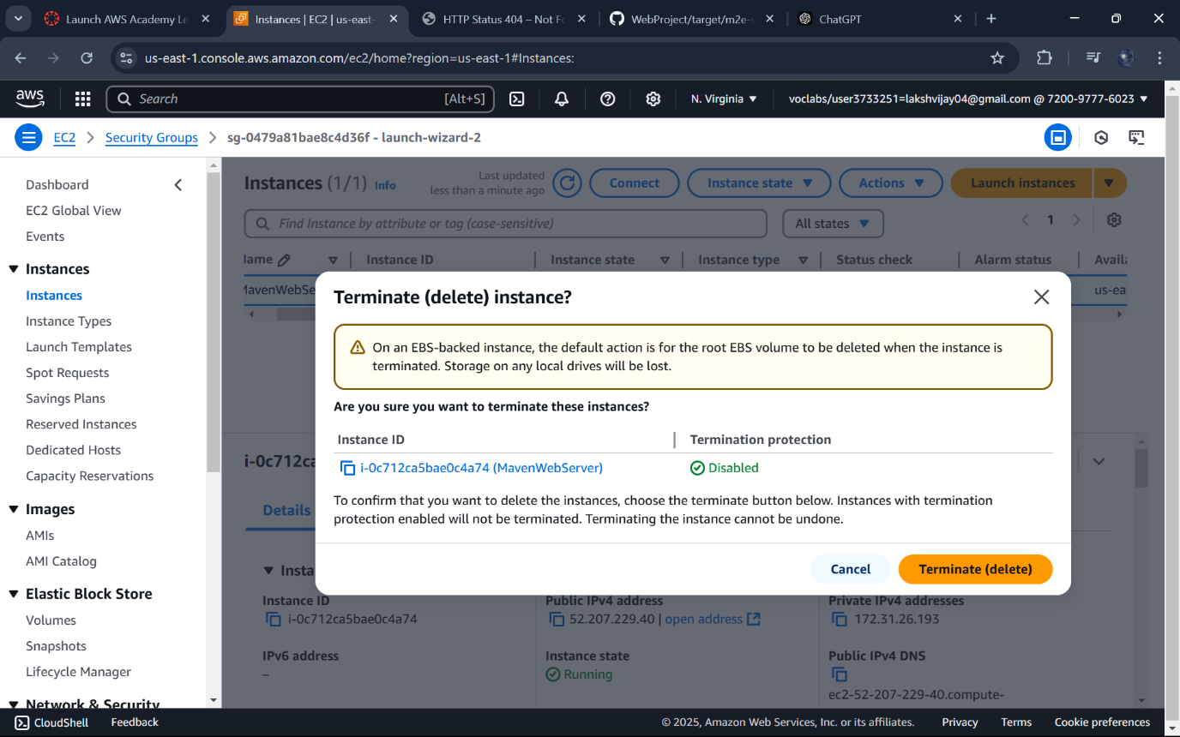

**The instance is terminated successfully.**



**End lab to avoid charges.**

**Click on Yes.** 